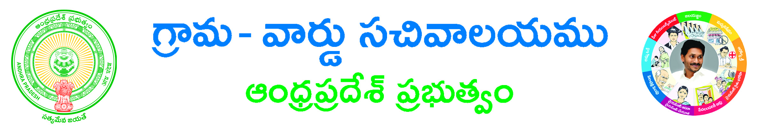

**Mutation and Title Deed Cum Pattadar PassBook**

**Applicant Details**

**Applicant type*: 🞏 Indian Citizen 🞏 NRI**

**Service type*: 🞏 Mutation 🞏 Mutation and title deed cum e-pass book**

**AADHAR Card No *: _________________________________________ (for Indian citizen)**

**Authentication Type*: 🞏 OTP 🞏 Biometric (for Indian citizen)**

**Enter the identity of the NRI *: __________________________ (if Applicant type NRI)**

**Document Details:-**

**District*:______________________________________ Mandal*:______________________________________**

**Village *:______________________________________ Division*:_______________________________________**

**Caste*:________________________**

**Mutation Category*: 🞏New Registration 🞏 Backlog Mutation 🞏 Succession**

**Mutation Sub Category *:🞏 purchase 🞏 will Deed 🞏 Gift Deed**

**If Mutation Category is New Registration / Backlog Mutation and Mutation Sub Category is purchase:-**

|  |  |  |  |  |  |  |  |
| --- | --- | --- | --- | --- | --- | --- | --- |
| **Seller Name** | **Seller address** | **Survey No./Sub division** | **Khata No.** | **Extent of Area** | **Document No.** | **Document Date** | **Village** |
|  |  |  |  |  |  |  |  |
|  |  |  |  |  |  |  |  |
|  |  |  |  |  |  |  |  |

**If Mutation Category is New Registration / Backlog Mutation and Mutation Sub Category is will Deed:-**

|  |  |  |  |  |  |  |  |
| --- | --- | --- | --- | --- | --- | --- | --- |
| **Testator Name** | **Testator address** | **Survey No./Sub division** | **Khata No.** | **Extent of Area** | **Document No.** | **Document Date** | **Village** |
|  |  |  |  |  |  |  |  |
|  |  |  |  |  |  |  |  |
|  |  |  |  |  |  |  |  |

**If Mutation Category is New Registration / Backlog Mutation and Mutation Sub Category is Gift Deed:-**

|  |  |  |  |  |  |  |  |
| --- | --- | --- | --- | --- | --- | --- | --- |
| **Donor Name** | **Donor address** | **Survey No./Sub division** | **Khata No.** | **Extent of Area** | **Document No.** | **Document Date** | **Village** |
|  |  |  |  |  |  |  |  |
|  |  |  |  |  |  |  |  |
|  |  |  |  |  |  |  |  |

**If Mutation Category is Succession:-**

**Succession Details:-**

**Successor Name*: ______________________ Name Deceased *: ______________________**

**Relation with Deceased *: ________________ Sy.No./Sub division *: ______________________**

**Khata. No. *: ______________________ document No. if any: ______________________**

**Total extent (Acs/Gts) *: ____________ Extant of Area (Acs/Gtc) *: ______________________**

**Sub Registrar *: ______________________ Village *: ______________________**

**AADHAR Card No *: __________________________ Authentication Type*: 🞏 OTP 🞏 Biometric**

**Applicant Details:-**

**AADHAR Card No *: __________________________ Buyer Name*: ______________________**

**Father Name/Husband *: ___________________ Gender*: __________________________________**

**DOB: ____________________________ Buyer Khata No.*: ______________________**

**Permanent Address:**

**State *: __________________________________ Door No*: __________________________________________**

**Locality / Land Mark: __________________________ District*:________________________________________**

**Mandal*:________________________________ Village / Ward *:__________________________________**

**Pin code: __________________________________**

**Address to send the e-passbook:**

**State *: __________________________________ Door No*: __________________________________________**

**Locality / Land Mark*: __________________________ District*:________________________________________**

**Mandal*:________________________________ Village / Ward *:_______________________________________**

**Pin code*: __________________________________ Mobile*: _______________________________**

**Phone No.: _______________________________ E-Mail : ____________________________________________**

**Remarks. _______________________________ Ration Card No.: _______________________________________**

**Delivery Type*: 🞏 Manual 🞏 Local post🞏 Non Local post**

**Documents List:**

**(NOTE: 1.Total size of Upload Document should not exceed 3 MB.2. All Upload Documents should be in PDF Format Only)**

1. **Application Form\***
2. **Registered Document Copies\***
3. **Old Pattadar Passbook/Title deed/ (Seller PPB/TD) \***
4. **Tax Receipts if any**
5. **Recent Passport Size photo.**
6. **Signature \***
7. **NRI proof document * (If applicant Type NRI)**

**Applicant signature**